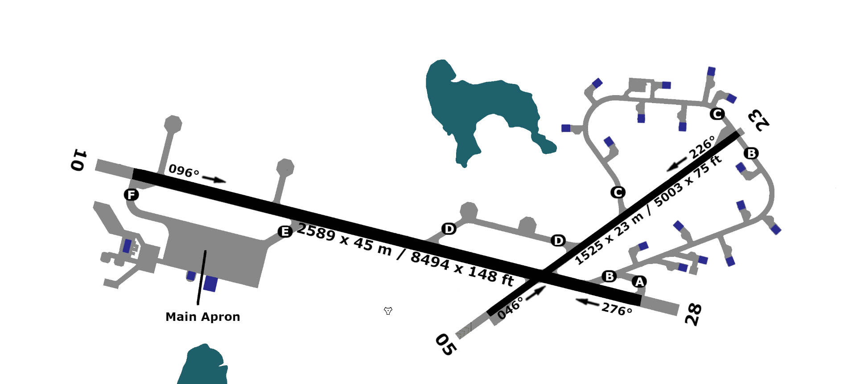
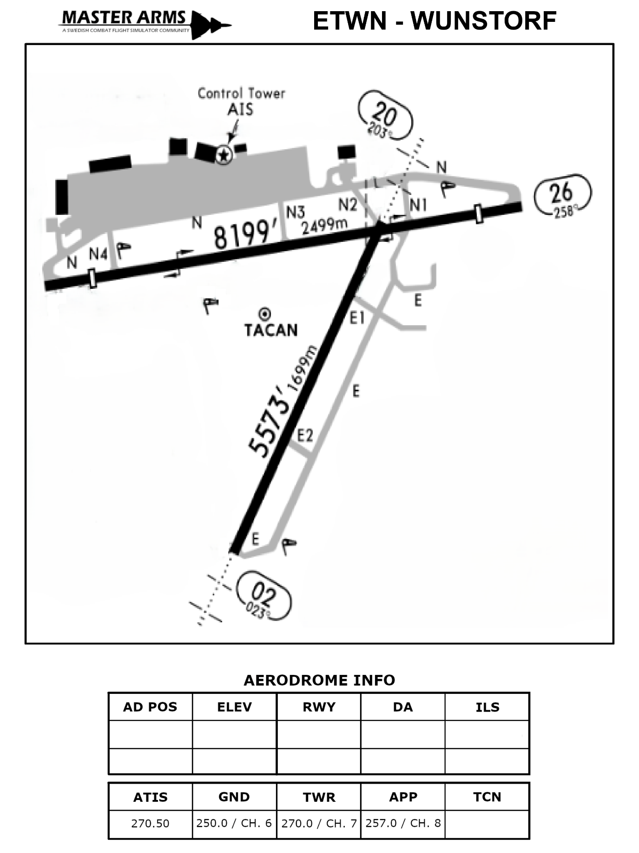


191 ft
203 ft
111.90
51°49”04’S
59X
197 ft
233 ft
EGYP – MT PLEASANT
23
05
28
10
1.0
2589 m
2589 m
1525 m
1525 m
58°28”19’W
1.0

